Dimeter

📏 What is Dimeter
# Source: AI Source: Provided by: [Data Path: Persons Table -> ID Column: 1, Name_En Column: Motasem Essam] -> From: [Chatgpt (GPT-4-turbo)] on [8/2/2025]
Term | Definition
Dimeter | A poetic meter consisting of 2 metrical feet per line.

🧱 Structure:
# Source: AI Source: Provided by: [Data Path: Persons Table -> ID Column: 1, Name_En Column: Motasem Essam] -> From: [Chatgpt (GPT-4-turbo)] on [8/2/2025]
- “Di-” = two
- So each line contains 2 feet (the type of feet varies).

📝 Example:
# Source: AI Source: Provided by: [Data Path: Persons Table -> ID Column: 1, Name_En Column: Motasem Essam] -> From: [Chatgpt (GPT-4-turbo)] on [8/2/2025]
From Richard Armour’s poem:
Men fight
Lose sight
Of right
In night
This is likely iambic dimeter → each line has 2 iambs: ˘ ´ | ˘ ´

🧠 Possible Variants:
# Source: AI Source: Provided by: [Data Path: Persons Table -> ID Column: 1, Name_En Column: Motasem Essam] -> From: [Chatgpt (GPT-4-turbo)] on [8/2/2025]
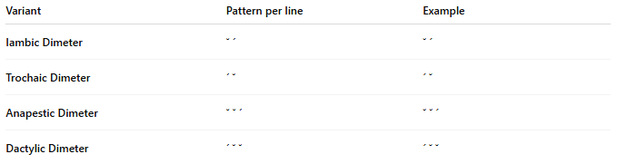
Variant | Pattern per line | Example
Iambic Dimeter | ˘ ´ | ˘ ´
Trochaic Dimeter | ´ ˘ | ´ ˘
Anapestic Dimeter | ˘ ˘ ´ | ˘ ˘ ´
Dactylic Dimeter | ´ ˘ ˘ | ´ ˘ ˘

🎭 Effect:
# Source: AI Source: Provided by: [Data Path: Persons Table -> ID Column: 1, Name_En Column: Motasem Essam] -> From: [Chatgpt (GPT-4-turbo)] on [8/2/2025]
- Short, punchy rhythm
- Useful for quick pacing, dialogue, or emphasis
- Often used in songs, hymns, and dramatic poetry

📚 Where It's Found
# Source: AI Source: Provided by: [Data Path: Persons Table -> ID Column: 1, Name_En Column: Motasem Essam] -> From: [Chatgpt (GPT-4-turbo)] on [8/2/2025]
Dimeter is relatively uncommon as a full poem meter but is found in:
- Short lyrical poems with a punchy, rhythmic effect
- Refrains or repetitive stanzas in ballads or songs
- Comic verse and nursery rhymes for brevity and bounce
- Choral responses or dialogue in classical and dramatic poetry
- Epigrams and aphoristic poetry, where conciseness is key
It’s often used for emphasis in alternating with longer lines or to break rhythm deliberately.

